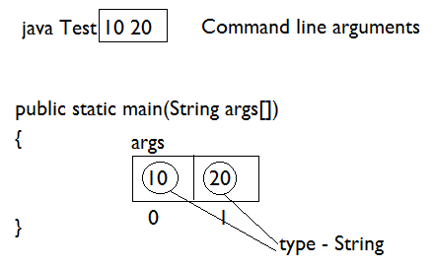

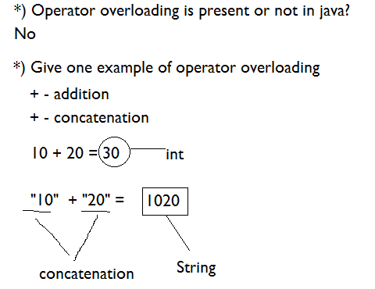

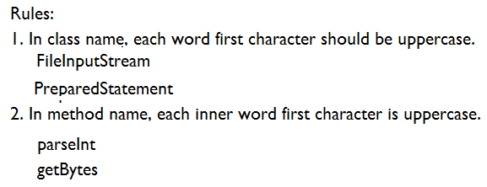

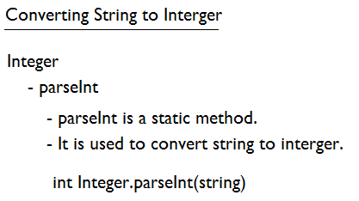

Program#1: Write a program to read 2 integer value using command line argument and find the sum.

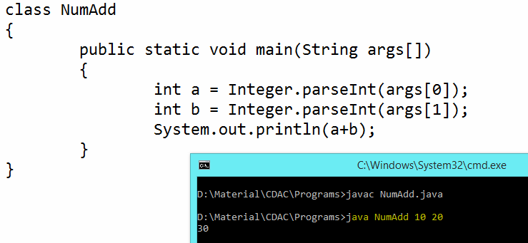

**Conditional and Looping Statements**

* If, else if, switch
* for loop
* while loop
* do while loop
* break & continue keyword
* Recursion

**If Statement**

* if statement consists of an expression followed by one or more statements.

**Syntax**

if(expression)

{

// Statements will execute if the expression is true

}

**Example#1**

public class Test

{

public static void main(String args[])

{

int x = 1;

if( x < 2)

{

System.out.print("This is if statement");

}

}

}

**Example#2  
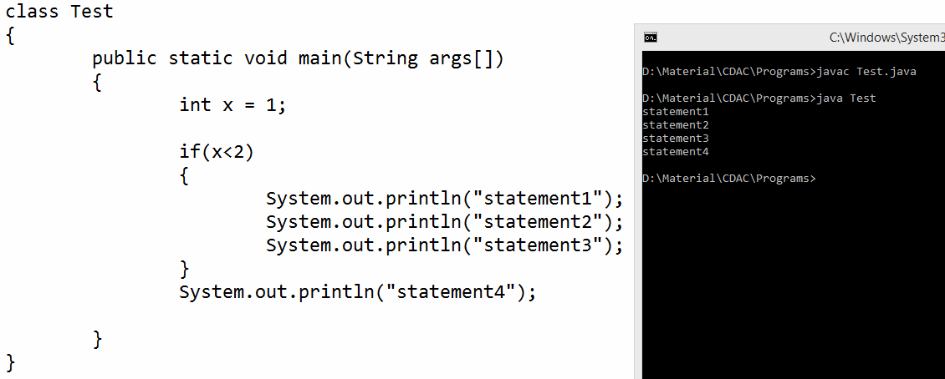**

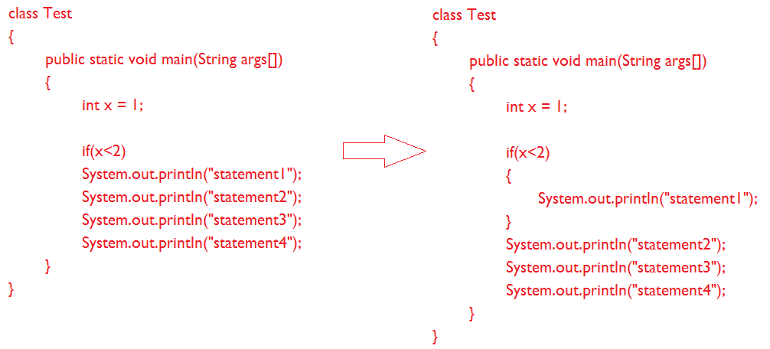

**Example#3**

class Test

{

public static void main(String args[])

{

int x = 1;

if(x>2)

System.out.println("statement1");

System.out.println("statement2");

System.out.println("statement3");

System.out.println("statement4");

}

}

**if-else statement**

**Syntax**

if(expression)

{

// Executes when the expression is true

}

else

{

// Executes when the expression is false

}

**Example**

class AgeChecker

{

public static void main(String args[])

{

int age = 20;

if(age >= 18)

{

System.out.println("You are eligible for voting");

}

else

{

System.out.println("You are not eligible for voting");

}

}

}

**If-else-if Statement**

**Syntax**

if(expression 1)

{

Statement(s) to be executed if expression 1 is true

}

else if (expression2)

{

Statement(s) to be executed if expression 2 is true

}

else if (expression3)

{

Statement(s) to be executed if expression 3 is true

}

else

{

Statement(s) to be executed if no expression is true

}

**Example**

class NumberChecker

{

public static void main(String args[])

{

int number = 0;

if (number > 0)

{

System.out.println("The number is positive.");

}

else if (number < 0)

{

System.out.println("The number is negative.");

}

else

{

System.out.println("The number is 0.");

}

}

}

**Switch**

switch(expression)

{

case x:

// code block

break;

case y:

// code block

break;

default:

// code block

}

* The value of the expression is compared with the values of each case.
* If there is a match, the associated block of code is executed otherwise default will execute.

**Example**

class NumberChecker

{

public static void main(String args[])

{

int a = 3;

switch(a)

{

case 1:

System.out.println("a is 1");

break;

case 2:

System.out.println("a is 2");

break;

case 3:

System.out.println("a is 3");

break;

default:

System.out.println("default");

}

}

}

**Fall through in switch case**

class NumberChecker

{

public static void main(String args[])

{

int a = 3;

switch(a)

{

case 1:

System.out.println("a is 1");

case 2:

System.out.println("a is 2");

case 3:

System.out.println("a is 3");

default:

System.out.println("default");

}

}

}

**For loop**

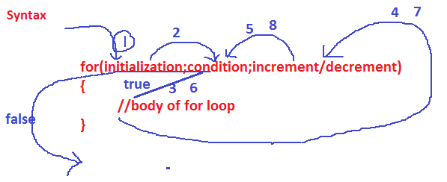

**Example#1**

class Test{

public static void main(String args[]){

for(int i=1;i<=5;i++){

System.out.println(i);

}

}

}

**Example#2**

class Test{

public static void main(String args[]){

for(int i=5; i>=1; i--){

System.out.println(i);

}

}

}

**Example#3**

Write a program to print all even numbers from 1 to 10.

class Test{

public static void main(String args[]){

for(int i=1; i<=10; i++){

if(i%2 == 0){

System.out.println(i);

}

}

}

}

**Example#4**

Write a program to print all even numbers from 1 to n.

class Test{

public static void main(String args[]){

int n = Integer.parseInt(args[0]);

for(int i=1; i<= n; i++){

if(i%2 == 0){

System.out.println(i);

}

}

}

}

**Example#5**

Write a program to find sum of all numbers from 1 to 5.

class Test{

public static void main(String args[]){

int sum = 0;

for(int i=1; i<=5; i++){

sum = sum +i;

}

System.out.println(sum);

}

}

**Example#6**

Write a program to find sum of all even numbers from 1 to 5.

class Test{

public static void main(String args[]){

int sum = 0;

for(int i=1; i<=5; i++){

if(i%2 == 0){

sum = sum +i;

}

}

System.out.println(sum);

}

}

**While Loop**

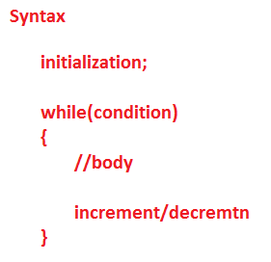

**Example#1**

class Test{

public static void main(String args[]){

int i = 1;

while(i<=5){

System.out.println(i);

i++;

}

}

}

**Example#2**

Write a program to display 5 to 1 using while loop.

class Test{

public static void main(String args[]){

int i = 5;

while(i>=1){

System.out.println(i);

i--;

}

}

}

**Example#3**

Write a program to print all even numbers from 1 to 10 using while loop.

....

**Example#4**

Write a program to print all even numbers from 1 to n.

...

**Example#5**

Write a program to find sum of all numbers from 1 to 5.

...

**Example#6**

Write a program to find sum of all even numbers from 1 to 5.

...

**Do While Loop**

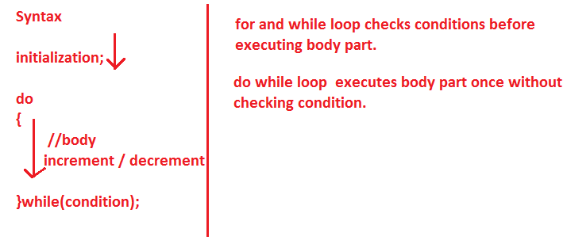

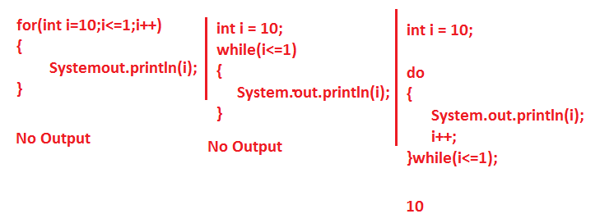

**Example#1**

Write a program to display 1 to 5 using do while loop.

class Test{

public static void main(String args[]){

int i = 1;

do{

System.out.println(i);

i++;

}while(i<=5);

}

}

**Example#2**

Write a program to display 5 to 1 using do while loop.

class Test{

public static void main(String args[]){

int i = 5;

do{

System.out.println(i);

i--;

}while(i>=1);

}

}

**Example#3**

Write a program to print all even numbers from 1 to 10 using do while loop.

....

**Example#4**

Write a program to print all even numbers from 1 to n using do while loop.

...

**Example#5**

Write a program to find sum of all numbers from 1 to 5 using do while loop.

...

**Example#6**

Write a program to find sum of all even numbers from 1 to 5 using do while loop.

...

**break**

class Test{

public static void main(String args[]){

for(int i=1;i<=10;i++){

if(i==5){

break;

}

System.out.println(i);

}

}

}

**Continue**

class Test{

public static void main(String args[]){

for(int i=1;i<=10;i++){

if(i==5){

continue;

}

System.out.println(i);

}

}

}

**Example**

Write a program to find sum of all even number and odd number from 1 to 10.

class EvenOddSum{

public static void main(String args[]){

int evensum = 0;

int oddsum = 0;

for(int i=1;i<=10;i++){

if(i%2==0){

evensum = evensum+i;

}

else{

oddsum = oddsum+i;

}

}

System.out.println("Even Sum = "+evensum);

System.out.println("Odd Sum = "+oddsum);

}

}

**Example**

Write a program to find factorial of a number.

class FactorialFinder{

public static void main(String args[]){

int fact = 1;

for(int i=5;i>=1;i--){

fact = fact * i;

}

System.out.println("Fact = "+fact);

}

}

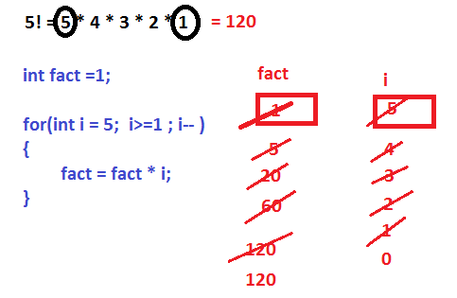

**Recursion**

* When a method call itself is called recursion.

**Example**

class RecursionDemo{

public static void main(String args[]){

int number = 3;

int res = factorial(3);

System.out.println("Fact = "+res);

}

static int factorial(int n){

if(n==0){

return 1;

}

else{

return n* factorial(n-1);

}

}

}

